

## WeTube

(Youtube Clone Application)

### Synopsis

**Department of Computer Engineering &Application Institute of Engineering & Technology**



### Submitted To: -

**Mr. Vinay Agrawal** (**Technical Trainer**)

### Submitted By: -

**Aditya Kumar Das (181500041)**

**Gaurav Kumar (181500233)**

**Prashant Verma (181500493)**

**Pulkit Ranjan (181500519)**

**Vishes Keshari (181500813)**



**Acknowledgement**

It gives us a great sense of pleasure to present the synopsis of the Mini Project **(WeTube – Youtube Clone Application)** undertaken during B.Tech IIIrd Year, this project itself is going to be acknowledgement to the inspiration, drive and technical assistance will be contribute to it by many individuals.

We owe special debt of gratitude to **Mr. Vinay Agrawal** (Technical Trainer Department of CEA) for providing us with an encouraging platform to develop this project which thus helped us in shaping our abilities towards a constructive goal and for his constant support and guidance to our work. His sincerity, Thoroughness and perseverance is being a constant source of inspiration for us. We believe that he will shower us with all his Extensively experienced ideas and insightful comments at different stages of the project & also taught us about the latest industry-oriented technologies.

We also do not like to miss the opportunity to acknowledge the contribution of all faculty members of the department for their kind guidance and co-operation.

Aditya Kumar Das (181500041)

Gaurav Kumar (181500233)

Prashant Verma (181500493)

Pulkit Ranjan (181500519)

Vishes Keshari (181500813)



## Table of Contents

1. **About Project** 4
2. **Features** 5
3. **Motivation** 6
4. **Future Prospects** 6
5. **DFD** 7
6. **Requirements**
   1. Hardware Requirements 8
   2. Software Requirements 8
7. **References** 8



**About the Project**

The Project that we are making is more of a skill gaining work by which we are seeking to learn different technologies and prospects of developing any software or application. Basically, we are going through each and every step so that in future we can easily make our own web app by the knowledge and experience gain by this.

WeTube is a video sharing service where users can watch, like, share, comment, and upload their own videos.

What is WeTube?

WeTube is a video streaming media web application solution to build a website similar to Youtube. It is designed to boost simplicity to both service providers and users.

What are the features of WeTube ?

WeTube web application has features such as create Profile, create channels, browse and Upload videos, Upload Stories, enabling us to share our content to a large audience with just some clicks.

Why choose WeTube ?

We can create effective videos of lectures, demonstrations, and more quickly and easily with minimal video equipment. With many students using smart phones, video is a great platform to reach them. **YouTube** is highly optimized for mobile devices and the majority of students are already using it. It is very effective and free of cost platform for promotion and advertisement.



### Features

* **Upload:** Users can create a channel and post their content in the app. In addition to that, users can also upload live streaming video in the app.
* **Stories**: The stories feature form a part of major social media apps. Users can use this feature to promote their videos.
* **Watch later:** Users can select the contents for watch later. These are saved in a separate category so people can watch from it whenever they want. They can also save videos under various labels.
* **Download**: Customers can download the content when they have a proper internet connection and stream it later.
* **Comments**: Users can view the comment sections on their videos and express their opinion about the videos. Recently YouTube has hidden the comments so that people who wish to see it can open the comments section.
* **Notification**: People will get notifications from the subscribed channels so that they can stream and watch it.
* **Playlist:** Video streaming clone script has facilities for users to create their playlist. They can change the settings as private or public according to their preference.



### Motivation

Recreating a popular web application is a fun way to learn a lot of complex programming skills. WeTube includes an authentication system, database, storage, live streaming ability and more.

The React DOM has components specifically designed to work with NodeJs that reduce lines of code, making server-side rendering comparatively easy.

The eagerness to know and learn how the application is made and how it works led us to take the project of WeTube. And this is more of a skill gaining work by which we are seeking to learn different technologies and prospects of developing any software or application. Basically, we are going through each and every step so that in future we can easily make our own app by the knowledge and experience gained from it.

# Future Prospects

The Future prospect of this project is to provide us with all the inside and outside details of making a web application, all the step involved and to know everything from minor to major details and to give us enough knowledge and experience, so that we can further develop our own application and improve it.

With enough technological knowledge we can further add any functionality and features of our own make it more user friendly and interactive. Our Goal will be to provide a web application for all requirements of user, whatever user seeks to find he will get there.



### 0-Level DFD

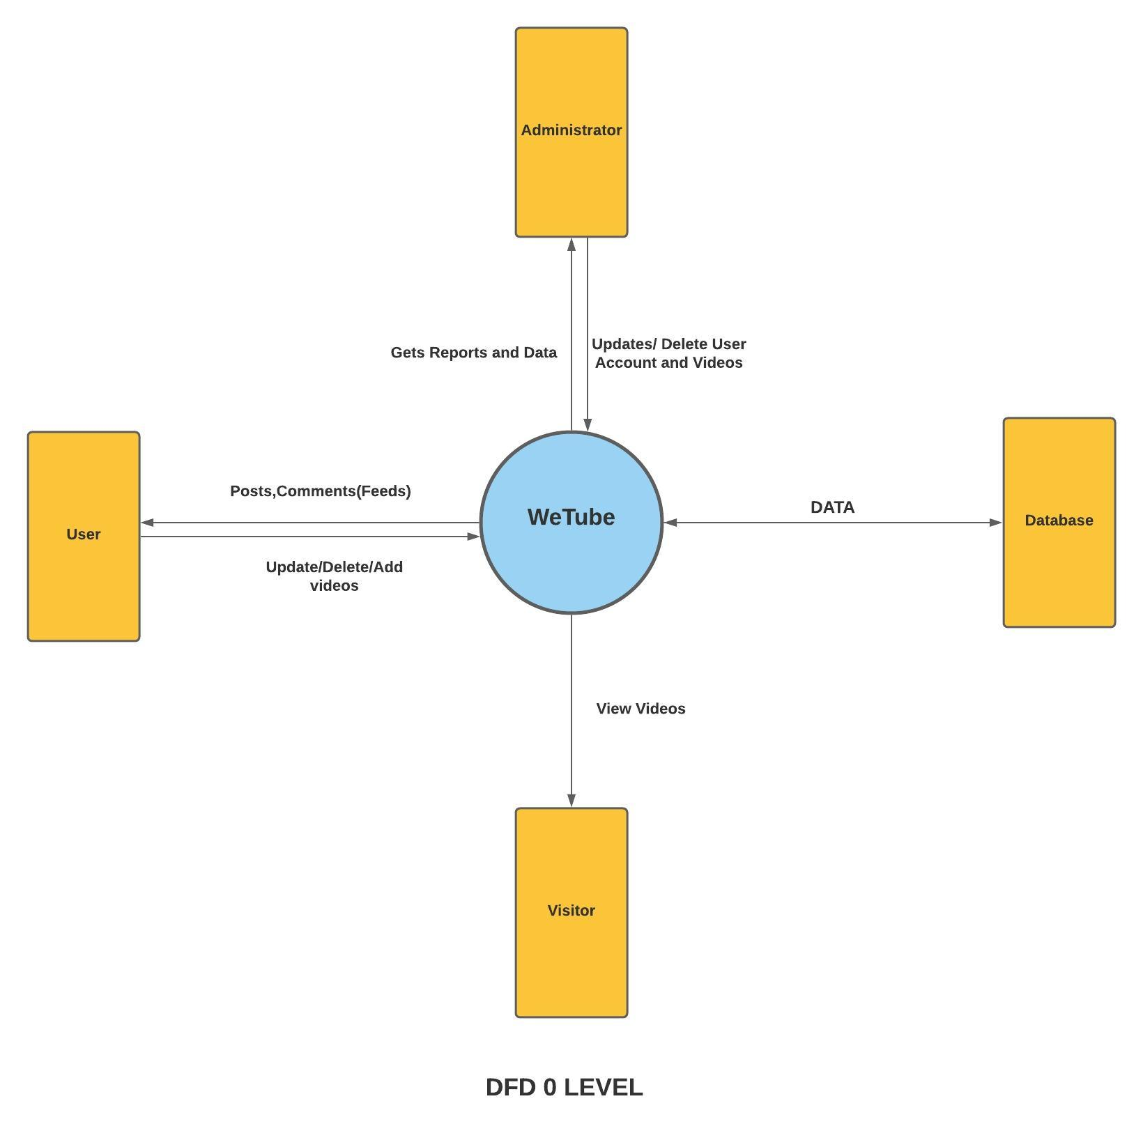



**Requirements**

1. **Hardware Requirements (Minimum):**
   1. i3 processor-based computer
   2. 2GB Ram
   3. 25 GB Hard Disk Space
2. **Software Requirements (Minimum):**
   1. Windows OS
   2. GitHub
   3. Micrsoft visual studio code
   4. Browser(Google chrome or any)
   5. Language used
      * HTML
      * CSS
      * JavaScript
      * React
      * Express
      * MongoDB
      * NodeJs

### REFERENCES

* [WWW.w3school.com](http://WWW.w3school.com/)
* [WWW.javatpoint.com](http://WWW.javatpoint.com/)
* [WWW.youtube.com](http://WWW.youtube.com/)
* Faculty Guidelines
* Mr.Vinay Agrawal